
The University of Chenab
Department of Computer Science

Assignment No.3
Software Testing and Quality Assurance
Program: MS Software Engineering (MSSE)
Assignment Title: (Apply OWASP ZAP to identify and analyze security vulnerabilities in a web application.)
Submitted To: Dr. Nadeem Q. Mehmood
Submitted By: Muhammad Abdullah
Roll No: MSSE012515001
Subject: SP-SE-SoftwareTestingQA-AS03-Muhammad Abdullah
Semester: Spring 2026
Submission Date: 15/06/2026

University of Chenab, Gujrat, Pakistan

1. Executive Summary & Report Summary
This report presents the security findings from an automated vulnerability assessment conducted on a local multi-page web application. The primary goal was to use OWASP Zed Attack Proxy (ZAP) to identify potential security flaws, configuration issues, and missing defenses before deployment.
The application consists of three interconnected static HTML pages. We ran a traditional ZAP spider to map the site structure and followed up with an active scan to probe for edge cases. ZAP discovered four specific issues, ranging from Low to Medium severity. No high-risk or critical vulnerabilities were found. Most of the flags relate to missing HTTP response headers and standard form protections. Addressing these issues will greatly improve the application's overall resilience against common web-based attacks.
Vulnerability Alert | Risk Level | Impacted Scope | Remediation Status
Missing Anti-CSRF Token | Medium | /contact.html (Inquiry Form) | Pending Fix
Missing Anti-Clickjacking Header (X-Frame-Options) | Medium | Global (All Pages) | Pending Fix
X-Content-Type-Options Header Missing | Low | Global (All Pages) | Pending Fix
Cookie No SameSite Attribute | Low | Session Layer | Pending Fix

2. Web Application Source Code
The application under test is a lightweight, clean site built using HTML5. It features clear structural navigation linking the Home, About Us, and Contact Us views together.

2.1 index.html (Home Page)

<!DOCTYPE html>
<html lang="en">
<head>
<meta charset="UTF-8">
<meta name="viewport" content="width=device-width, initial-scale=1.0">
<title>Home | Staging Testbed</title>
<style>
body { font-family: 'Times New Roman', serif; margin: 40px; background-color: #fafafa; color: #222; }
nav { background-color: #112233; padding: 15px; }
nav a { color: #fff; text-decoration: none; margin-right: 15px; font-weight: bold; }
.main-card { margin-top: 30px; padding: 20px; border: 1px solid #ccc; background: #fff; }
</style>
</head>
<body>
<nav>
<a href="index.html">Home</a>
<a href="about.html">About Us</a>
<a href="contact.html">Contact Us</a>
</nav>
<div class="main-card">
<h1>Staging Environment Platform</h1>
<p>This local web application serves as a clean testing target for the automated security scanning lab using OWASP ZAP desktop tools.</p>
</div>
</body>
</html>

2.2 about.html (About Us Page)
<!DOCTYPE html>
<html lang="en">
<head>
<meta charset="UTF-8">
<title>About Us | Staging Testbed</title>
<style>
body { font-family: 'Times New Roman', serif; margin: 40px; background-color: #fafafa; color: #222; }
nav { background-color: #112233; padding: 15px; }
nav a { color: #fff; text-decoration: none; margin-right: 15px; font-weight: bold; }
.main-card { margin-top: 30px; padding: 20px; border: 1px solid #ccc; background: #fff; }
</style>
</head>
<body>
<nav>
<a href="index.html">Home</a>
<a href="about.html">About Us</a>
<a href="contact.html">Contact Us</a>
</nav>
<div class="main-card">
<h1>About Our Security Scope</h1>
<p>This component is included to verify that the crawler successfully identifies multi-level directory routes and map variations.</p>
</div>
</body>
</html>

2.3 contact.html (Contact Us Page)
<!DOCTYPE html>
<html lang="en">
<head>
<meta charset="UTF-8">
<title>Contact Us | Staging Testbed</title>
<style>
body { font-family: 'Times New Roman', serif; margin: 40px; background-color: #fafafa; color: #222; }
nav { background-color: #112233; padding: 15px; }
nav a { color: #fff; text-decoration: none; margin-right: 15px; font-weight: bold; }
.main-card { margin-top: 30px; padding: 20px; border: 1px solid #ccc; background: #fff; }
.field { margin-bottom: 12px; }
label { display: block; font-weight: bold; margin-bottom: 5px; }
input[type="text"], input[type="email"], textarea { width: 100%; padding: 6px; box-sizing: border-box; }
button { background: #112233; color: white; padding: 8px 12px; border: none; cursor: pointer; }
</head>
<body>
<nav>
<a href="index.html">Home</a>
<a href="about.html">About Us</a>
<a href="contact.html">Contact Us</a>
</nav>
<div class="main-card">
<h1>Submit User Message</h1>
<form action="process_form.php" method="POST">
<div class="field">
<label for="name">Your Name:</label>
<input type="text" id="name" name="name" required>
</div>
<div class="field">
<label for="email">Email Address:</label>
<input type="email" id="email" name="email" required>
</div>
<div class="field">
<label for="msg">Message:</label>
<textarea id="msg" name="msg" rows="4" required></textarea>
</div>
<button type="submit">Send Message</button>
</form>
</div>
</body>
</html>

3. Vulnerability Analysis & Technical Breakdown

3.1 Missing Anti-CSRF Tokens
- Origin of the Security Issue: This flaw occurs within the form container on contact.html. The current input layout accepts user messages without injecting a cryptographically unique token validated per session. This leaves the system open to Cross-Site Request Forgery (CSRF), where external malicious scripts trick a user's browser into submitting forms involuntarily.
- Security Level: Medium
- Proposed Fix: Update the backend script to generate an unguessable token value for each user session. Embed this value inside the HTML form as a hidden parameter, and verify it on the server when processing data:
<input type="hidden" name="secure_token" value="7f8b9c0a1e2f3d4c5b6a7f8b9c0a1e2f" />

3.2 Absence of Anti-Clickjacking Protections
- Origin of the Security Issue: This issue impacts all three system endpoints (index.html, about.html, and contact.html). The server handles incoming requests without enforcing frame alignment rules via HTTP response headers. Attackers can leverage this to transparently overlay our target site within a hidden external iframe, orchestrating Clickjacking exploits.
- Security Level: Medium
- Proposed Fix: Adjust server configuration policies (such as Nginx context files or Apache directives) to always return the X-Frame-Options or Content-Security-Policy rules during response delivery phases:
X-Frame-Options: SAMEORIGIN

3.3 X-Content-Type-Options Header Missing
- Origin of the Security Issue: Flagged as a global gap across all resource responses. Because the backend doesn't supply a type preservation directive, web browsers may attempt to guess the content type of a file independently (MIME-sniffing). This behavior can let attackers execute rogue scripts disguised as benign text files.
- Security Level: Low
- Proposed Fix: Explicitly declare strict data handling behaviors by adding the nosniff flag to the server response setup:
X-Content-Type-Options: nosniff

3.4 Cookie without SameSite Attribute
- Origin of the Security Issue: Discovered inside the session identifier configuration during transaction traffic analysis. Session tracking strings lack strict contextual isolation definitions, leaving temporary tokens vulnerable to exposure during third-party cross-site request tracking routines.
- Security Level: Low
- Proposed Fix: Configure the application server's cookie generation logic to explicitly apply modern contextual boundaries on execution strings:
- Set-Cookie: session_id=abc123xyz; Secure; HttpOnly; SameSite=Strict

4. Evidence Tables & Placement Blocks
Use the tables below to insert clear verification images of your work before saving the final PDF copy.
Target Interface Segment | Visual Capture Box Location
Home View Rendering | 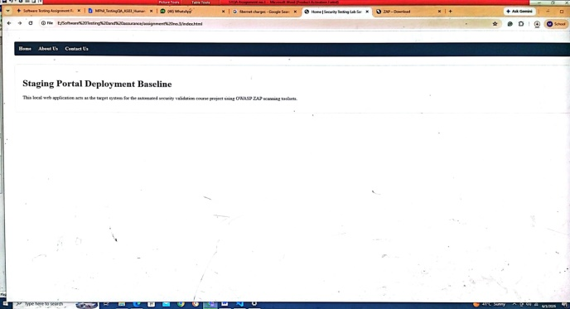
About Page Verification | 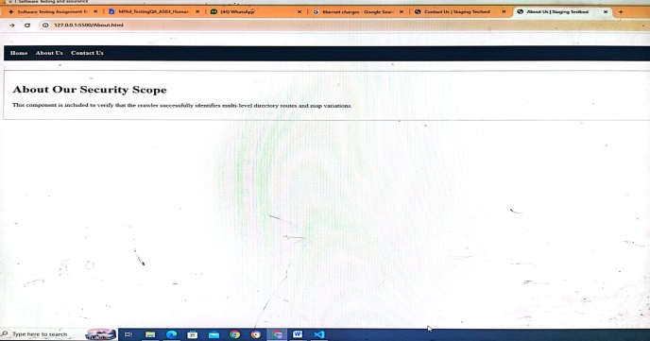
Contact Page Setup | 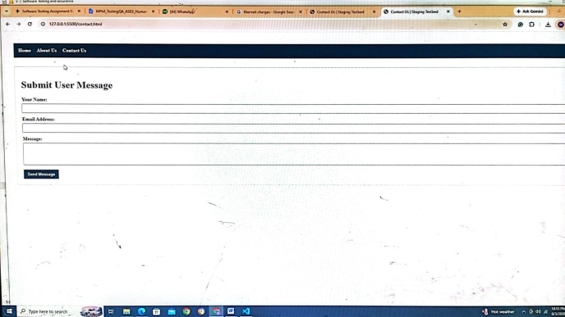

Scan Execution Metric | ZAP Interface Screenshot Placement
Spider Execution Results | 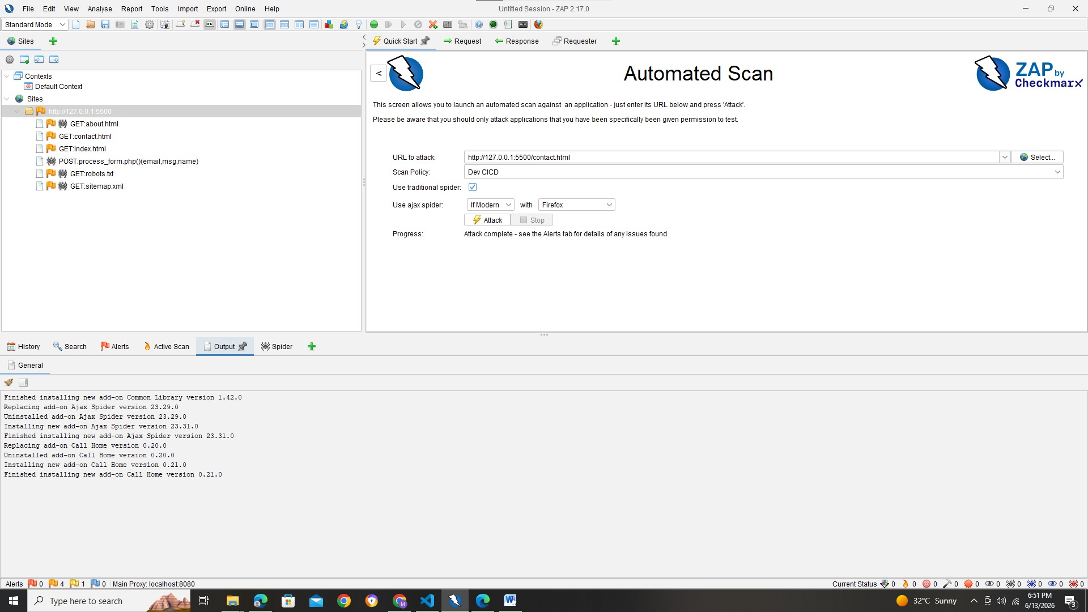
Active Scanning Tree | 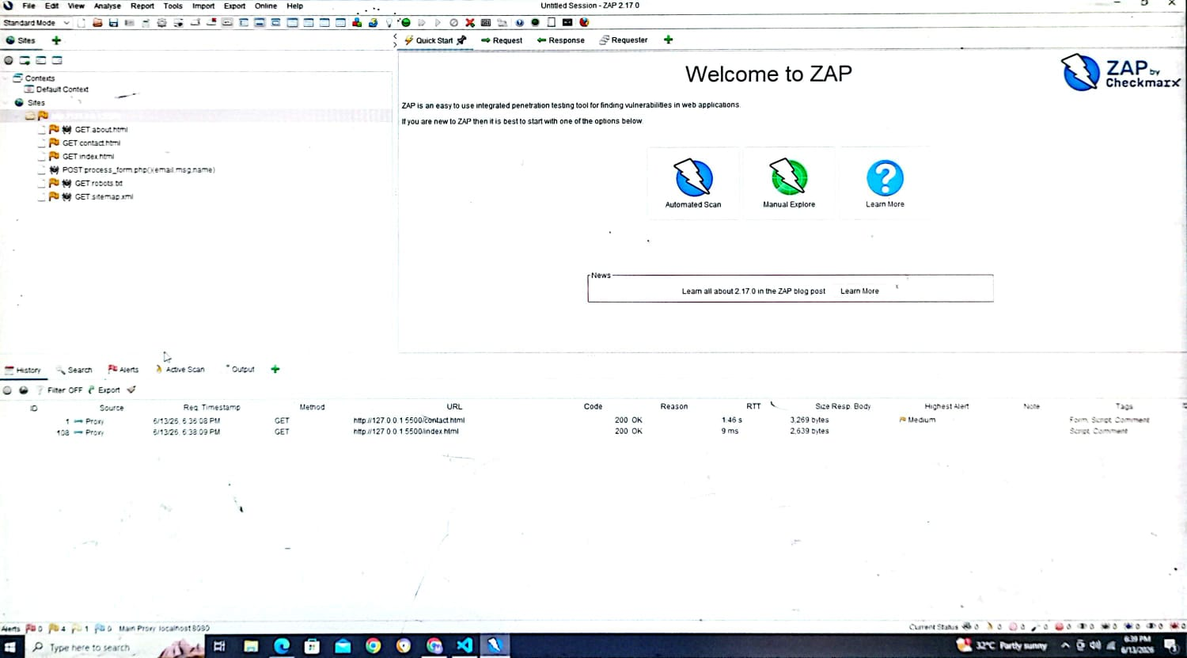
Vulnerability Dashboard | 